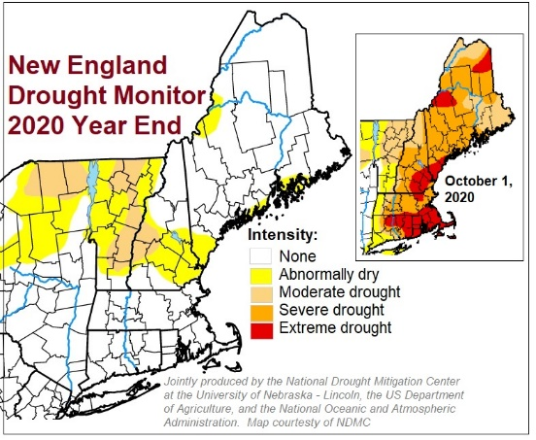
January 2021 Horticultural Hints for Social Media
The heavy rains (and early snow) we experienced in December helped our trees to fill their roots with the water that they did not get last summer and fall. As of the beginning of the year, New England is now largely drought-free. Trees and bushes need to carry water into the winter because it is inaccessible once the ground has frozen. Without the late precipitation, our woody plants would have suffered additional stresses.

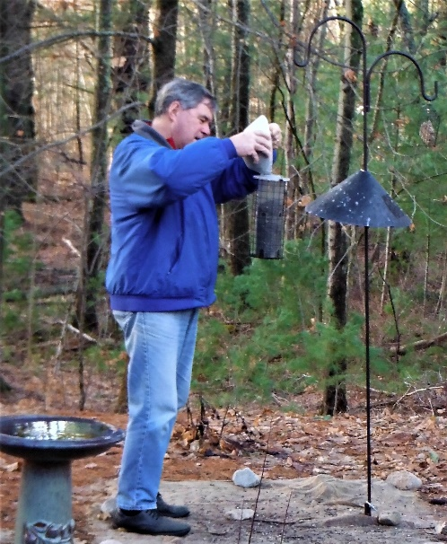
Winter is for the birds, and they’ll appreciate your assistance. Winter means little water is available. If you put out a heated bird bath that keeps fresh water available for drinking and bathing, you’ll have a steady stream of visitors. If you also have out seeds and suet, you will have an unending show outside your window. And in the spring, your new friends, having grown accustomed to your property. will eat the insects you’re not so fond of feeding.

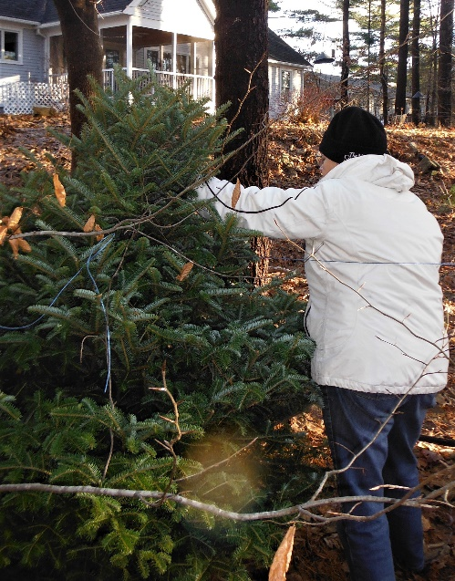
Christmas trees aren’t just for the holidays. They can brighten our spirits all winter. Instead of throwing it out to the curb, when you take down your tree, place it upright, out of strong winds, to provide shelter for birds. If located near feeders, the trees provide a safe place for birds to eat or to wait their turn.

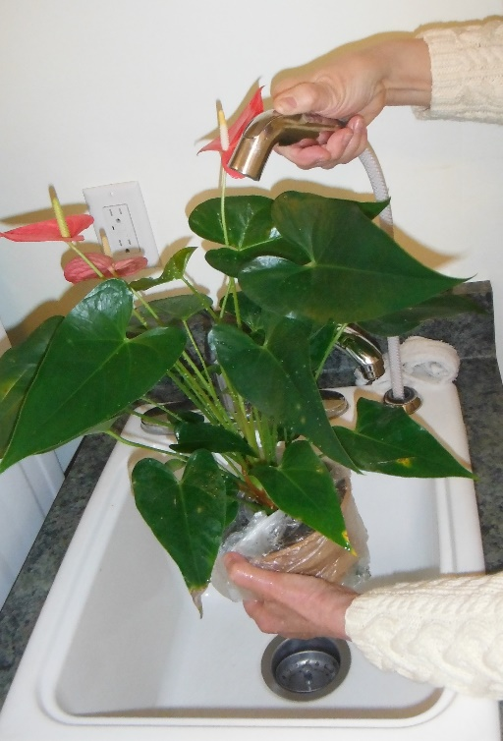
A January bath improves houseplant health. Use a plastic bag to cover the soil and place the plant in a sink or tub and spray gently with tepid water. By removing dust and any household pollutants, you’ll do your plants a world of good as well as improve their appearance. Wiping each leaf with a clean cloth can serve the same purpose but is much more time consuming.

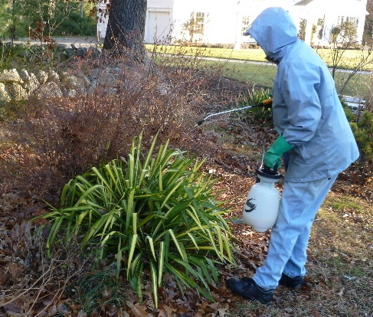
Spray your plants to save them. Winter is cruel to our plants. Harsh winds dry the leaves of the evergreens and hungry deer, rabbits and other varmints will eat almost anything they find. On warm dry days, you can spray evergreens with an anti-desiccant such as Wilt-Pruf that helps the leaves and needles retain moisture. A monthly spraying on another warm day with an animal repellent may prevent leaves and flower buds from disappearing into the stomachs of browsers.
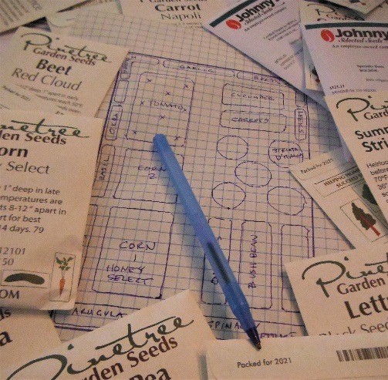
It seems like everyone wants a vegetable garden in 2021. If you haven’t ordered vegetable seeds already, get busy. Most companies’ seed catalogs are available on line, so there’s no need to wait for a printed catalog. Overwhelmed in 2020 and despite their planning for 2021, seed crop failures and the influx of new buyers have put a strain on some seed supplies. Be prepared with an alternate selection for your first choice.

